Stack Overflow

🎓 Definition
# Source: ScreenShots Source: Provided by: [Persons Table -> ID Column: 1, Name_En Column: Motasem Essam] -> Tool: [Lightshot Program] -> From [Site: https://stackoverflow.com/questions/] on [11/13/2025]
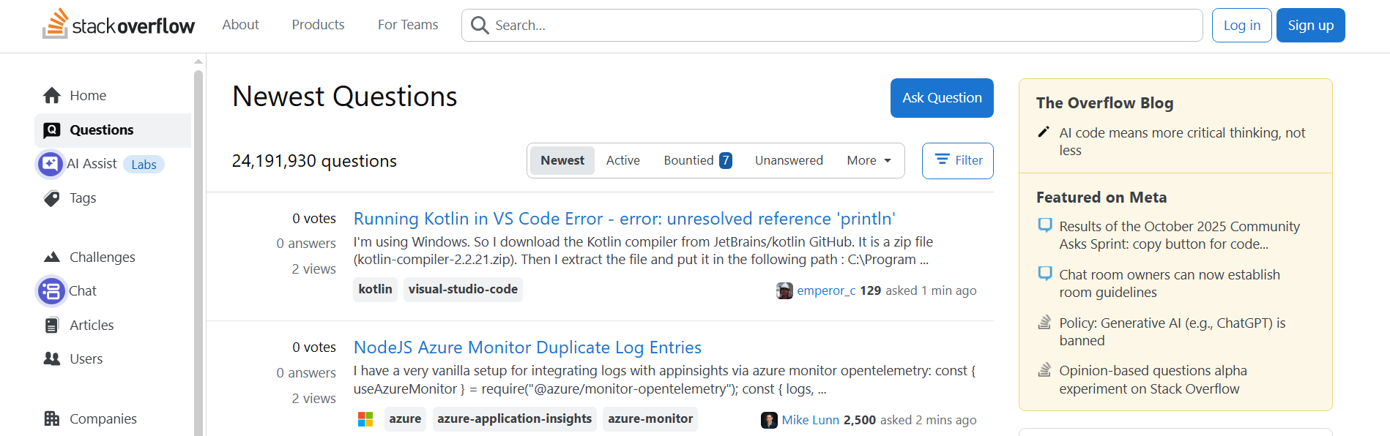
# Source: AI Source: Provided by: [Data Path: Persons Table -> ID Column: 1, Name_En Column: Motasem Essam] -> From: [ChatGPT] on [11/13/2025]
Stack Overflow — https://stackoverflow.com/ — is the largest and most well-known Q&A site for programming and software development. It is part of the Stack Exchange network but focuses exclusively on coding and technical topics. Here’s a detailed breakdown:

📌 Overview
# Source: AI Source: Provided by: [Data Path: Persons Table -> ID Column: 1, Name_En Column: Motasem Essam] -> From: [ChatGPT] on [11/13/2025]
- Stack Overflow is a question-and-answer platform for programmers and developers.
- Users ask questions about programming languages, frameworks, software tools, algorithms, debugging, and best practices.
- Experienced developers provide answers, often with code examples, explanations, or references.

⚡ Key Features
# Source: AI Source: Provided by: [Data Path: Persons Table -> ID Column: 1, Name_En Column: Motasem Essam] -> From: [ChatGPT] on [11/13/2025]
- Voting & Reputation System: High-quality answers get upvoted, and users earn reputation points to unlock privileges like editing, voting, or moderating.
- Tags & Search: Questions are organized with tags (e.g., python, javascript, reactjs) to make searching for solutions easier.
- Community Moderation: Experienced users and moderators enforce rules, close off-topic questions, and maintain content quality.
- Free Access: Anyone can read and search; creating an account allows posting questions, answering, and voting.

✅ Purpose
# Source: AI Source: Provided by: [Data Path: Persons Table -> ID Column: 1, Name_En Column: Motasem Essam] -> From: [ChatGPT] on [11/13/2025]
- To provide fast, reliable, and high-quality solutions to programming problems.
- Serves as a knowledge repository for developers, helping both beginners and professionals.

🛡️ Safety & Legality
# Source: AI Source: Provided by: [Data Path: Persons Table -> ID Column: 1, Name_En Column: Motasem Essam] -> From: [ChatGPT] on [11/13/2025]
- Fully legal and safe to use.
- Does not host pirated software or files.
- Focuses entirely on knowledge sharing in programming and software development.

📌 Summary
# Source: AI Source: Provided by: [Data Path: Persons Table -> ID Column: 1, Name_En Column: Motasem Essam] -> From: [ChatGPT] on [11/13/2025]
Stack Overflow is the go-to platform for programming Q&A, part of the Stack Exchange network. It is widely trusted by developers worldwide and emphasizes accurate, peer-reviewed technical solutions.

